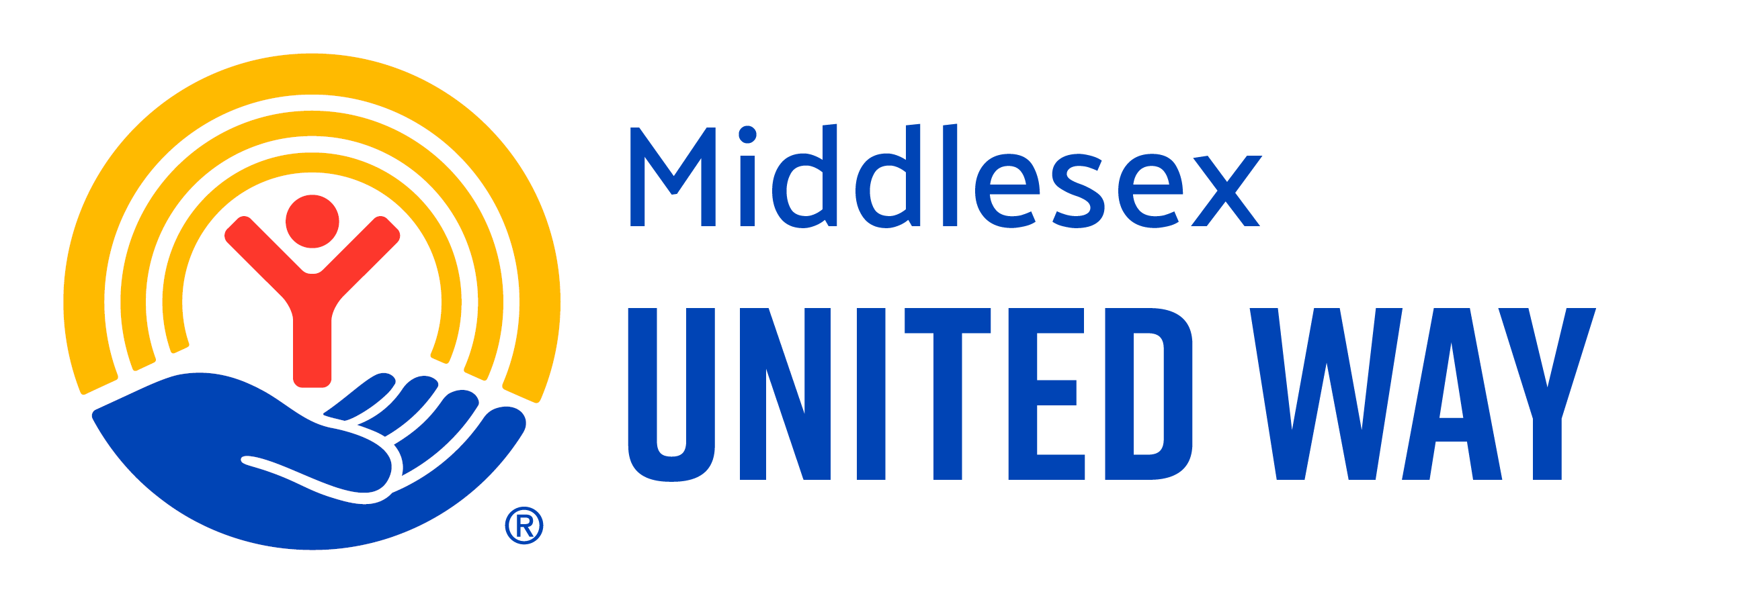

Community Impact Grant Application
Fiscal Year 2026-2027
Please refer all questions to Brian Thompson, Director of Community Impact
brian.thompson@middlesexunitedway.org
  - 860-346-8695 (ext. 17)

Eligibility
The following requirements must be met for an applicant to receive Community Impact Grant funds and remain in good standing with the Middlesex United Way:
- The organization must be a 501(c)(3) or have a fiscal sponsor that is a 501(c)(3).
- The proposed program must serve the constituents of the communities of the Middlesex United Way: Chester, Clinton, Cromwell, Deep River, Durham, East Haddam, East Hampton, Essex, Haddam, Killingworth, Middlefield, Middletown, Portland, Old Saybrook, and Westbrook. All funds must be used serving only these communities and their residents.
- Programs must align with Middlesex United Way’s Vision, Values, and Commitment to Diversity. Applicants will need to serve the goals of at least one Community Impact Area: Youth Opportunity, Financial Security, Healthy Communities, Community Resiliency
- Funds must be expended between July 1, 2026, and June 30, 2027. Year-End Reports will be due May 31, 2027.
- Middlesex United Way Community Impact Grant funds cannot fund capital expenditures, scholarship programs, or any third party or contract. All grant funds must be spent on the intended purpose.
- Applicants must demonstrate that they are not financially reliant on MUW Community Impact Grant funds. MUW funds must be a part of a plurality of revenue streams; overreliance on MUW will disqualify the applicant.
- Applications must have a minimum request of $5,000 and a maximum of $30,000.
- Applicants must commit to attending four quarterly community gatherings during the grant cycle. These gatherings will focus on enhancing program impact, providing essential resources, and fostering collaboration among partners.
- Partners funded for FY25-26 must be in good standing with MUW. Reports must be submitted on time and illustrate that Community Impact Grant Funded Partners met all goals or worked to address causes that impeded success. Funded Partners must have delivered on all parts of the Funding Partner Criteria and Agreement FY2025-2026, including promoting Middlesex United Way and participating in Workplace Campaigns.
Grantee Commitments
As part of the Middlesex United Way partnership, grantees are required to:
- Participate in four quarterly community gatherings designed to enhance program delivery and collaboration.
- Submit timely and complete reports detailing progress and outcomes.
- Promote Middlesex United Way through organizational communications.

Organization Information
- Organization Name:
- Organization Address:
- Organization Phone:
- Organization Web Presence:
  - Website Link:
  - Twitter Handle:
  - Instagram Handle:
  - LinkedIn Link:
- Employer Identification Number (EIN):

If using a fiscal agent:
- Fiscal Agent Name:
- Fiscal Agent Address:
- Fiscal Agent Employer Identification Number:
- Fiscal Agent Contact (Name, Email, Phone):

Contact Information:
You are required to update MUW when there are changes to any of this information. Please indicate which person is designated to receive requests for Quarterly Reports.
- Executive Director/President/CEO Name:
  - Email:
  - Phone:
- Primary Contact Name & Title:
  - Email:
  - Phone:
- Secondary Contact Name & Title:
  - Email:
  - Phone:

Program/Project Justification

Community Impact Areas
Middlesex United Way invests in programs and initiatives that align with one or more of the following Community Impact Areas. These descriptions are intended to provide guidance, not limitation. Applicants are encouraged to describe how their work contributes to outcomes within an area, rather than fit their work into a prescribed model.

- Youth Opportunity
We support a continuum of opportunity that begins in early childhood and extends through adolescence and into adulthood. Our investments focus on high-quality early education, youth development programs, and strong family engagement — building pathways for every young person to thrive from cradle to career.

- Healthy Communities
We strengthen the health of our region by expanding access to mental health services, physical healthcare, food, and wellness resources. Our approach is rooted in local partnerships that meet people where they are and address the full spectrum of community well-being.

- Financial Security
We work to ensure that individuals and families can meet their basic needs, build wealth, and prepare for the future. Our efforts support workforce development, job training, financial literacy, and access to safe, affordable housing — laying the foundation for long-term economic stability.

- Community Resiliency
We bring people and organizations together to address systemic issues, respond to community crises, and strengthen the networks that hold us together. This includes supporting inclusive planning, infrastructure, and civic partnerships that allow communities to adapt and thrive.
Equity
Equity is not a separate goal — it is embedded into everything we do. It shapes how we invest resources, define outcomes, and build partnerships. Applicants are expected to consider equitable access, participation, and outcomes across all areas of their work.

Program Information & Narrative

- Name of program to be funded:

- What is your organization’s Mission?

- Provide a brief description of your organization including the organization’s history, scope of work, and how the project/program aligns with your organization.

- Provide a 1–3-page program/project narrative describing the scope of your work, a high-level timeline and budget for how grant funds will be spent, and major program benchmarks for the 2026 – 2027 Grant Year.

- How does your program/project advance the Mission of Middlesex United Way’s? How does your organization’s Mission and project fit within the Impact Area you are applying for?

- Please provide a Needs Statement describing the focus population(s) served and describe the specific need(s) your focus population faces. Please share quantitative and qualitative data specific to your focus population’s demographics as well, including the number of unduplicated clients served, and where they live. Needs Statement must include evidence that the work your organization addresses a specific and documented need. We encourage you to provide data and references from as local to your area of service as possible such as zip codes, neighborhoods, and/or local cities, instead of macro level data. This can include reference to municipal or regional studies, plans, assessments, or other documentation.
Please describe how the needs and barriers you identify differ across populations, communities, or geographies, and how your program design accounts for these differences.

Goals, Objectives, Outcomes, and Metrics
Please complete the matrix below and consider the following questions:
What are the overall program goals, specific objectives, and desired outcomes in FY26-27? Metrics: How will you know if you are successful? What metrics will you use? Evaluators will be looking to see that each Goal and corresponding Objectives, Outcomes, and Metrics are S.M.A.R.T: Specific, Measurable, Attainable, Relevant, and Time-Based. Be sure each row reflects S.M.A.R.T goal making criteria.

In addition, please describe how your program design ensures equitable access, participation, and outcomes for the populations you serve. Please note any intentional adaptations, outreach strategies, or accountability measures.

 | Goal | Objective(s) | Outcome(s) | Metric(s)
1
2
3
4

- Please describe your plan to collect data necessary to meet the expectations of this grant. This includes demographic data of clients, and may pre- and post- intervention surveys or evaluations, surveys, or other specific data collection tools.

- What other services or agencies do you refer clients? In the past year, how many successful referrals were made and to where?

Organizational Expectations
- In what ways do you promote your services to reach your populations?

- How many paid staff members do you have dedicated full-time or part-time to this work?

- What were some of the challenges you faced in the last 12 months, and how did you overcome those?

- What improvements will be made to this program/project from last year?

- How does your organization learn from the communities it serves and use that learning to improve programs over time?

- What new funding sources have you applied for in the past 12 months? If so, which were you awarded?

- An expectation of all funded partners is to publicly acknowledge that you’ve received Middlesex United Way Community Impact Funds. What is your plan to announce that you’ve received funds and promote Middlesex United Way?

- What support can the Middlesex United Way staff, board, or volunteers provide to help your organization, project, or program be successful?

Financial Information and Required Attachments

- Grant amount requested FY2026-27:
- Grant amount received in FY2025-26:
- Organization budget for FY2026-27 – any format
- Organization’s audit, audit review, or budget to actuals for most recently completed fiscal year – any format
- Program specific budget for which funding is requested- any format

- Two letters of support from either an organization you partner with, organization you are funded by, a local elected official, or another community stakeholder familiar with your organization’s impact.
- Leadership, Staff & Board Demographics Chart required for all applicants; MUW-provided template is located on application download page.
- Copy of IRS 501(c)(3) Determination

Submission
I hereby agree that all information provided in this application is accurate and true.

Name:

Title:

Date:

